

Three-Day Financial Budget Tracker Using Python

Soniya Pariyar
International American University (IAU)
AIM 401: Python Programming for Data Science
Professor, Dhiraj Basyal
September 17, 2026

Three-Day Financial Budget Tracker Using Python

Abstract
Managing money is an important part of daily life. People often have a fixed amount of money that they want to spend each day or during a particular period. Keeping track of spending manually can sometimes be difficult, especially when there are multiple days and different amounts of spending. A simple computer program can make this process easier by automatically adding expenses and checking them against a budget.
This assignment presents a simple financial budget tracker developed using Python. The program is designed to track money spent over three days. The user has a daily budget of $20, which results in a total budget of $60 for three days. The program first asks the user for their name and initializes the total spending amount to zero. It then uses a for loop to repeat the spending process three times. For each day, the user enters the amount of money spent. The program converts the input into a floating-point number, adds it to the total, and checks whether the user has exceeded the $20 daily budget.
After the three-day loop is completed, the program displays the total money spent and checks whether the user stayed within the $60 total budget. The program uses only basic Python concepts, including variables, primitive data types, input, output, arithmetic operators, a for loop, and if/else statements. No custom functions, classes, collections, or external file input/output are used. This project demonstrates how basic programming concepts can be applied to a simple real-world financial problem.

Introduction
Financial management is a useful skill in everyday life. People need to know how much money they spend and whether their spending is within a planned budget. A budget gives a person a limit for spending and can help them make better decisions about their money. Even a small program can be useful for recording expenses and checking whether spending is within a given limit.
Python is a programming language that can be used to solve many different types of problems. It provides simple programming structures such as variables, operators, loops, and conditional statements. These features make it possible to create a basic financial tracking program without using complicated programming techniques (Python Software Foundation, n.d.-c).
The purpose of this assignment is to create a quick financial tool that tracks spending for three days. The program uses a daily budget of $20. Therefore, if the user spends more than $20 on a particular day, the program informs the user that they are over the daily budget. If the user spends $20 or less, the program informs the user that they are under the daily budget.
The program also calculates the total amount spent during the three days. Since the daily budget is $20, the total budget for three days is $60. After collecting all three spending amounts, the program compares the total with $60. If the total is less than or equal to $60, the program displays that the user stayed under the total budget. If the total is greater than $60, it displays that the user went over the total budget.
This project is intentionally simple because the assignment requires the use of basic Python programming structures. The program does not use custom functions, user-defined classes, lists, tuples, dictionaries, sets, or external file input/output. This makes the program suitable for practicing fundamental programming concepts.

Problem Statement
People can easily lose track of their daily spending when they do not record their expenses. For example, a person may have a daily budget of $20 but spend different amounts on different days. At the end of several days, it may be difficult to calculate the total manually.
The problem addressed by this project is how to create a simple program that can record spending for three days and automatically determine whether the user is staying within their budget.
The program needs to perform the following tasks:
- Ask the user for their name.
- Create a variable called total_spent and set it to zero.
- Repeat the spending process three times.
- Ask the user to enter the money spent for each day.
- Convert the spending input into a number using float().
- Add each day's spending to the total.
- Check whether the daily spending is greater than $20.
- Display an appropriate daily budget message.
- Display the total amount spent after three days.
- Check whether the total spending is less than or equal to $60.
- Display the appropriate overall budget message.
The problem can therefore be solved using basic Python programming structures without requiring advanced features.

Objectives

General Objective
The general objective of this project is to develop a simple Python program that tracks a user's spending over three days and checks whether the spending remains within a daily and total budget.

Specific Objectives
The specific objectives of the program are:
- To practice using Python variables.
- To receive information from the user using input().
- To convert user input into a floating-point number using float().
- To initialize and update a running total.
- To use a for loop to repeat a task three times.
- To use an if/else statement for daily budget checking.
- To use comparison operators such as > and <=.
- To calculate total spending using an arithmetic operator.
- To display the final spending result.
- To practice basic Python programming without using advanced programming structures.
- To understand how programming can be applied to a simple financial problem.
Requirements and Restrictions
The program was developed according to the boundaries given in the assignment. The allowed features include variables, primitive data types, standard operators, input parsing, output formatting, conditional structures, and basic loops.
The program uses the following allowed features:
Feature | Use in the Program
Variables | Store name, daily spending, and total spending
str | Store the user's name
int | Used with range(3) and the initial total
float | Store daily spending amounts
input() | Receive user information
float() | Convert spending input into a number
Arithmetic operator | Add spending amounts
for loop | Repeat the process three times
if/else | Check daily and total budgets
print() | Display program results

The following features were not used because they are forbidden by the assignment:
- Custom functions using def
- User-defined classes
- Lists
- Tuples
- Dictionaries
- Sets
- External file input/output
- Advanced string slicing
- Advanced string methods
The program therefore remains within the required boundaries.
Methodology
The program was developed step by step by breaking the problem into smaller parts. First, the user name and total spending variable were created. Second, a loop was added to repeat the spending process three times. Third, daily spending was collected and added to the total. Fourth, a conditional statement was used to check the daily budget. Finally, another conditional statement was used after the loop to check the overall budget.

The overall process can be represented as follows:
Start → Enter Name → Set Total to 0 → Repeat for 3 Days → Enter Daily Spending → Add to Total → Check Daily Budget → Repeat → Display Total → Check $60 Budget → Display Result → End
This approach makes the program easy to understand because each section performs a specific task.

Program Implementation

Step 1: Asking for the User's Name
The first line of the program asks the user to enter their name.
name = input("Enter your name: ")
The input() function allows the user to type information into the program. The entered value is stored in the variable called name.
For example, if the user enters:
Soniya
then the variable name contains the value "Soniya".
The name is not required for the calculations, but it is included because the assignment specifically requires the program to ask for the user's name.

Step 2: Creating the Total Spending Variable
The next line creates the total_spent variable.
total_spent = 0
The variable is initialized to zero because the user has not entered any spending yet. As the user enters the amount spent for each day, the program adds the amount to this variable.
For example, if the user spends $15 on the first day:
total_spent = 0 + 15
The new total becomes: 15
If the user then spends $25 on the second day:
total_spent = 15 + 25
The total becomes: 40
This process continues until all three days have been entered.

Step 3: Using the For Loop
The program needs to repeat the spending process three times. A for loop is suitable for this requirement.
for day in range(3):
The range(3) causes the loop to run three times. The loop can represent:
- First repetition → Day 1
- Second repetition → Day 2
- Third repetition → Day 3
Loops are useful when the same task needs to be performed multiple times. Python's for statement provides a simple way to repeat a block of code (Python Software Foundation, n.d.-b).
Step 4: Getting Daily Spending
Inside the loop, the program asks the user to enter the money spent that day.
spent = float(input("Enter money spent today ($): "))
There are two important parts in this statement.
First, input() asks the user to enter an amount.
Second, float() converts the entered value into a floating-point number. This is important because spending can contain decimal values.
For example, the user could enter: 15.50
The program can store this as a numerical value of 15.50.
The value is stored in the variable spent.
Step 5: Adding Spending to the Total
After receiving the daily spending amount, the program adds it to the total.
total_spent = total_spent + spent
The right side of the statement takes the previous total and adds the current day's spending.
For example:
Initial total = $0
Day 1 = $15
New total = $15

Day 2 = $25
New total = $40

Day 3 = $18
New total = $58
This allows the program to maintain a running total throughout the loop.
Step 6: Checking the Daily Budget
The daily budget is $20. Therefore, the program checks whether the amount spent is greater than 20.
if spent > 20:
print("Over your $20 budget today!")
else:
print("Great! Under budget today.")
The condition is:
spent > 20
The > operator means "greater than."
If the amount is greater than $20, the first message is displayed:
Over your $20 budget today!
If the amount is $20 or less, the else block is executed:
Great! Under budget today.
Conditional statements allow a program to execute different code depending on whether a condition is true or false (Python Software Foundation, n.d.-b).
Step 7: Displaying the Final Total
After the loop has completed all three repetitions, the program displays the total amount spent.
print("Total money spent over 3 days: $" + str(total_spent))
The print() function displays the result on the screen.
The str() function converts the numerical value of total_spent into a string so it can be combined with the text.
For example, if the total is 58, the output will be:
Total money spent over 3 days: $58.0
The final total is printed only after the loop is completely finished.
Step 8: Checking the Total Budget
The total budget for three days is $60. The program checks whether the total spending is less than or equal to 60.
if total_spent <= 60:
print("Overall Result: You stayed under your $60 total budget!")
else:
print("Overall Result: You went over your $60 total budget!")
The <= operator means "less than or equal to."
Therefore:
- If total spending is $60 or less → Under total budget
- If total spending is greater than $60 → Over total budget
For example, if the total is $58:
58 <= 60
This condition is true, so the program displays:
Overall Result: You stayed under your $60 total budget!
If the total is $65:
65 <= 60
This condition is false, so the program displays:
Overall Result: You went over your $60 total budget!

Complete Source Code
The following is the complete source code required for the assignment.
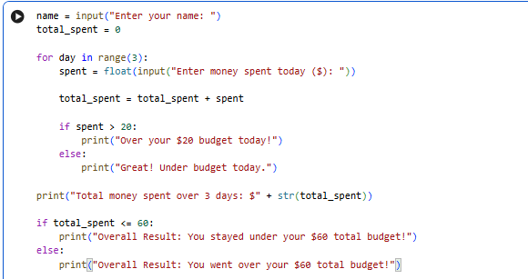

Program Flow
The program follows a simple sequence.
First, the program asks for the user's name. Second, it sets total_spent to zero. Third, the for loop starts and runs three times. During each repetition, the user enters the amount spent for the day.
The program adds the amount to total_spent. It then checks whether the amount is greater than $20. If it is greater, the program displays the over-budget message. Otherwise, it displays the under-budget message.
After three repetitions, the loop ends. The program then displays the total amount spent over the three days. Finally, it compares the total with the $60 budget and displays the overall result.
The process can be summarized as:
Start
↓
Enter Name
↓
Set total_spent = 0
↓
Repeat 3 Times
↓
Enter Daily Spending
↓
Add Spending to Total
↓
Is Spending > $20?
↓
Yes → Over Daily Budget
No → Under Daily Budget
↓
Loop Finished?
↓
Display Total Spending
↓
Is Total <= $60?
↓
Yes → Under Total Budget
No → Over Total Budget
↓
End

Testing and Results
Testing was performed by entering different spending values to make sure that both daily and overall budget conditions work correctly.

Test Case 1: Under Daily and Total Budget
For the first test, the following amounts were entered:
Day | Money Spent | Daily Result
Day 1 | $15 | Under budget
Day 2 | $18 | Under budget
Day 3 | $20 | Under budget
Total | $53 | Under total budget
The total is:
15 + 18 + 20 = 53
Since each daily amount is $20 or less, all three days are under the daily budget. The total of $53 is also less than $60.
Test Case 2: One Day Over Budget but Total Under Budget
For the second test, the following amounts were entered:
Day | Money Spent | Daily Result
Day 1 | $15 | Under budget
Day 2 | $25 | Over budget
Day 3 | $18 | Under budget
Total | $58 | Under total budget
The total is:
15 + 25 + 18 = 58
The second day's spending is greater than $20, so the program displays the daily over-budget message. However, the total is $58, which is still less than $60. Therefore, the overall result says that the user stayed under the total budget.

Test Case 3: Total Budget Exceeded
For another test, the user could enter:
Day | Money Spent | Daily Result
Day 1 | $25 | Over budget
Day 2 | $22 | Over budget
Day 3 | $20 | Under budget
Total | $67 | Over total budget
The total is:
25 + 22 + 20 = 67
The first two days are greater than $20, so the program displays the daily over-budget message for those days. The total is $67, which is greater than $60. Therefore, the final result states that the user went over the total budget.

Sample Program Output
One example of the program output is shown below.

Output Screenshot
Figure 1:
Python Source Code Executed in Google Collab
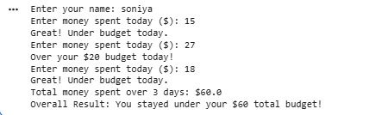
The example shows that the user entered $15 on the first day, $25 on the second day, and $18 on the third day. The second day's spending was greater than the $20 daily budget, so the program displayed the over-budget message. The total spending was $58, which was within the $60 total budget.
Figure 2:
Program Output in Google Colab
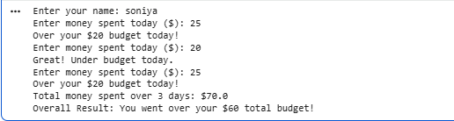
The screenshot should clearly show that the program runs without errors and produces the expected output. The source code in the screenshot should match the code provided in this report and the code uploaded to the GitHub repository.
GitHub Repository
The complete source code should be submitted through the GitHub repository as required by the assignment. The repository provides access to the Python source code and allows the submitted program to be reviewed.
GitHub Repository Link:
https://github.com/Soniya94/AIM-python
The .py file in the repository contains the complete source code for the Three-Day Financial Budget Tracker. The code does not use custom functions, classes, collections, or external file input/output.

Figure 3:
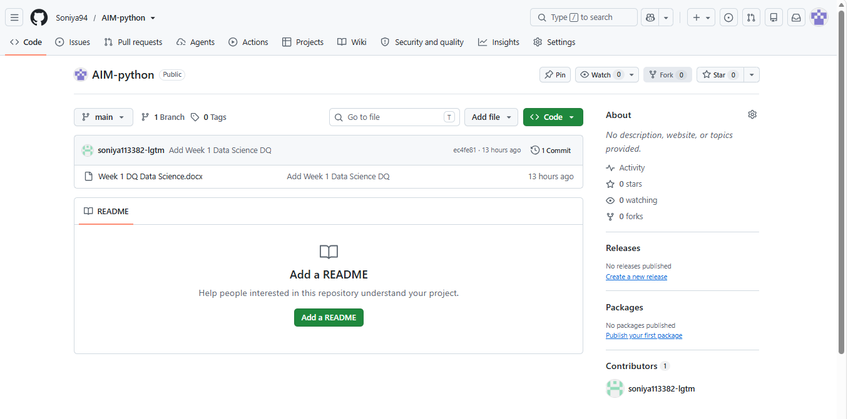`

Discussion
The completed program demonstrates several fundamental programming concepts. The first concept is the use of variables. Variables are used to store information that the program needs during execution. In this program, name, spent, and total_spent are used for different purposes.
The second concept is user input. The program uses input() to allow the user to enter information. The name is received as text, while the spending amount is converted into a floating-point number.
The third concept is repetition. The program uses a for loop because the same spending process must happen three times. Without a loop, the same code would have to be written separately for each day. A loop makes the program shorter and easier to maintain.
The fourth concept is conditional decision-making. The program uses if/else statements to compare spending with the budget. The daily condition checks whether spending is greater than $20. The final condition checks whether total spending is less than or equal to $60.
Another important concept demonstrated by the program is accumulation. The total_spent variable keeps a running total. Each new spending amount is added to the previous total. This is a common programming technique for calculating totals.
The program is also useful because it shows how programming can solve a real-life problem. Although the financial calculation is simple, the same basic ideas can be used in larger financial applications. Larger programs may use databases, graphical interfaces, functions, and other advanced features, but the basic logic can still be based on variables, loops, arithmetic, and conditions.
Limitations
Although the program successfully completes the required task, it has some limitations.
First, the program only tracks spending for three days. The user cannot choose a different number of days because the assignment specifically requires the loop to repeat three times.
Second, the daily budget is fixed at $20. The user cannot enter a different daily budget.
Third, the total budget is also fixed at $60. The program does not calculate a different total budget based on another number of days.
Fourth, the program does not check whether the user enters invalid input. For example, if the user enters text instead of a number for spending, the float() conversion would produce an error. Input validation could be added in a more advanced version.
Fifth, the program does not permanently save spending information. Once the program stops running, the entered information is lost because external file input/output is not used.
Finally, the program does not display detailed information about individual expenses. It only records the total amount spent for each day.
These limitations are acceptable for this assignment because the goal is to practice basic Python programming concepts rather than develop a complete financial application.
Possible Future Improvements
The program could be improved in several ways in a future version.
One improvement would be allowing the user to enter their own daily budget instead of using a fixed $20 budget. This would make the program more flexible.
Another improvement would be allowing the user to choose how many days they want to track. For example, the program could allow tracking for 7 days, 14 days, or 30 days.
Input validation could also be added. The program could check whether the user has entered a valid number before performing the calculation. This would prevent errors when incorrect input is entered.
A future version could also categorize expenses, such as food, transportation, entertainment, and other expenses. However, such features would require additional programming concepts and may involve collections, which are outside the boundaries of the current assignment.
Another possible improvement would be creating a graphical user interface. A graphical interface could make the program easier for users who do not want to use the terminal.
The program could also save spending information to a file or database. This would allow users to access their previous spending records. However, external file input/output is specifically forbidden in the current assignment, so it has not been included.
Learning Outcomes
This project helped develop an understanding of several basic Python programming concepts.
First, I learned how to create and update variables. The total_spent variable was particularly useful because it stored the running total.
Second, I learned how to receive input from the user. The input() function makes it possible for the program to interact with the user.
Third, I practiced type conversion by using float(). Since money can include decimal values, using a floating-point number is appropriate for this simple exercise.
Fourth, I practiced using a for loop. The loop allowed the program to repeat the same task three times without writing the same code three separate times.
Fifth, I practiced conditional statements. The if/else structure allowed the program to make decisions based on spending amounts.
Sixth, I learned how arithmetic operators can be used to calculate a running total.
Finally, I learned how basic programming concepts can be combined to create a small practical application. This project shows that even a short Python program can be used to solve a simple real-world problem.
Conclusion
The Three-Day Financial Budget Tracker was successfully developed using basic Python programming concepts. The program asks the user for their name, records spending for three days, checks each day's spending against a $20 budget, calculates the total spending, and checks the total against a $60 budget.
The program uses variables, input, type conversion, arithmetic operators, a for loop, and if/else statements. These features are enough to complete the required financial tracking task without using advanced programming structures.
Testing with different spending amounts showed that the program correctly identifies whether the user is over or under the daily budget. It also correctly calculates the total and determines whether the user stayed within the $60 three-day budget.
The project provided practical experience with basic Python programming and showed how programming can be applied to everyday situations. Although the program is simple and has some limitations, it meets the requirements of the assignment and provides a foundation for developing more advanced financial applications in the future.

References
GitHub. (n.d.). GitHub documentation. https://docs.github.com/en
Python Software Foundation. (n.d.-a). Built-in functions. Python documentation. https://docs.python.org/3/library/functions.html
Python Software Foundation. (n.d.-b). More control flow tools. Python documentation. https://docs.python.org/3/tutorial/controlflow.html
Python Software Foundation. (n.d.-c). The Python tutorial. Python documentation. https://docs.python.org/3/tutorial/

